Oaklodge Surgery, 32 Miller Street, Hamilton ML3 7EN

ACCEPTABLE BEHAVIOUR CONTRACT

We are committed to promoting access to our services and offering choice wherever possible in the services we provide and the way we deliver them. An acceptable behaviour contract is an individual written agreement between a patient and their GP Practice.
The contract is between (Patients name).......................................and Oaklodge Surgery and is valid from the date of application to register.
The Conditions:
(Patients name).............................................. agrees to the following:
1. I agree to cancel any appointments I am unable to attend with as much notice as possible.
2. I agree to Oaklodge Surgery’s DNA (did not attend) policy - if after I have missed 3 appointments without notifying the surgery I will be removed from the Practice list and will have to register with a different practice.
3. I agree to adhere to Oaklodge Surgery’s repeat prescription policy and agree to allow 2 working days before collecting my repeat prescription from the surgery and 3 working days if it goes to the pharmacy.
4. I agree to refrain from using abusive or offensive language, making threats of violence or aggressive behaviour and to treat all staff fairly and with respect; in person, on the phone, in writing or on social media.

Breach of this Contract:
If (Patients name) ............................ fails to adhere to the above conditions, they will be removed from the practice list. This contract serves as an initial warning in the event of breaches occurring.
When removal results from number 4 above, any patients for whom this person is responsible ie. child or cared for individual and who live at the same address, will also be removed to avoid any risk of further abuse to clinicians undertaking home visits for said child or cared-for individual.
• Oaklodge Surgery will ensure you are dealt with quickly, fairly and in a courteous and helpful manner.
• Oaklodge Surgery will ensure that staff take responsibility for resolving or dealing with your query or that they refer it to an appropriate colleague

Declaration:
I confirm that I understand the meaning of this contract and that the consequences of breaking the conditions of the contract.
Signed by.................................................................................... (the patient)
Name:......................................................................................... Date .......... / .......... / ..........
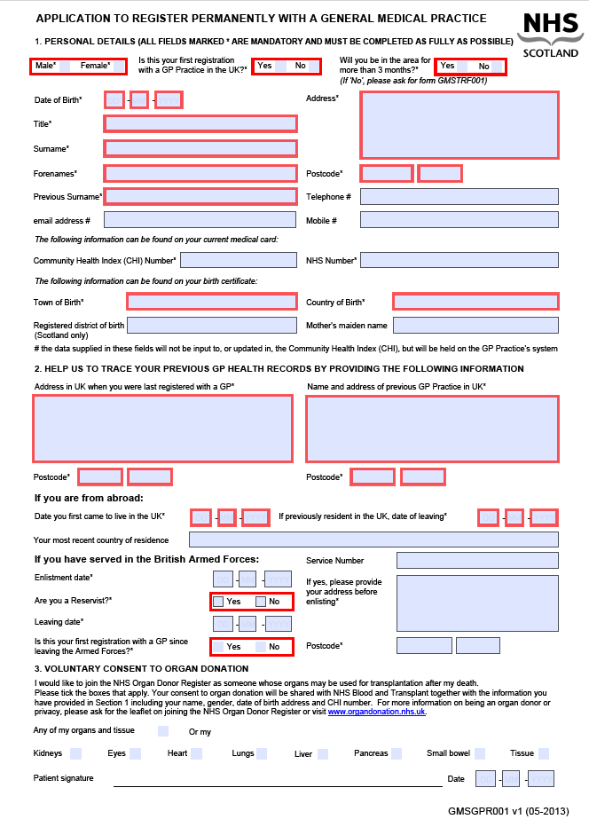
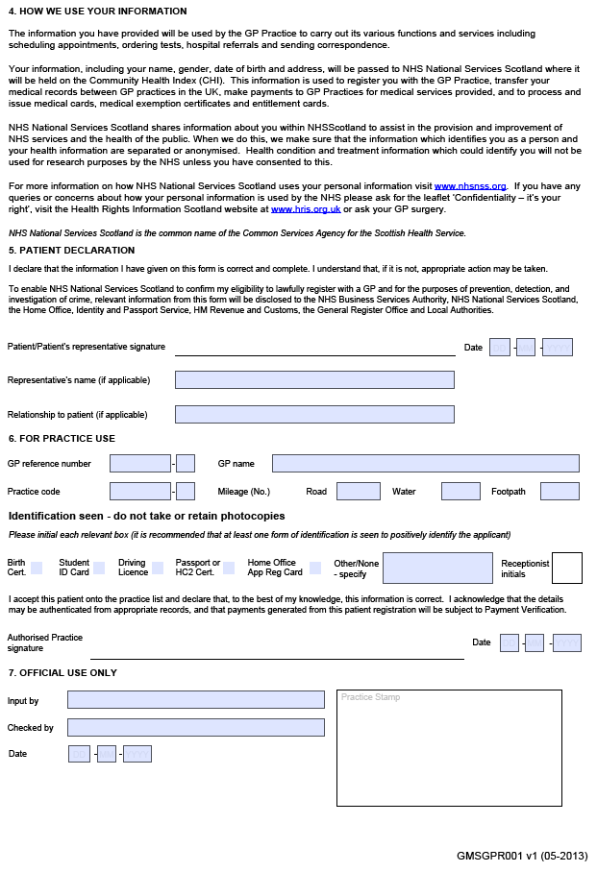

NEW PATIENT INFORMATION SHEET

SURNAME ……………………………………….. FORENAME ……………………..

ADDRESS ……………………………………………………………………………………………

TEL. NO ……………………………………………. POST CODE ……………….

MARITAL STATUS ……………………………….. DATE OF BIRTH ………………

ETHNIC ORIGIN………………………………………………

PREVIOUS GP
………………………………………………………………………………………………

GENERAL HISTORY.

HEIGHT ……………………………………………….

WEIGHT ………………………………………..

BLOOD PRESSURE …………………………………..

CHOLESTEROL ………………………………

URINALYSIS ………………………………………….

LAST TETANUS INJECTION …………………………………………

Please list any illness you either have at present or any serious illness, accident or operations in the past.

………………………………………………………………………………………………

………………………………………………………………………………………………

………………………………………………………………………………………………

Please list any medication you are taking:

……………………………………………………………………………………………

………………………………………………………………………………………………

………………………………………………………………………………………………

Please list any allergies you have:

………………………………………………………………………………………………

How much tobacco or how many cigarettes do you smoke daily?

……………………………………………………………………………………………

How much alcohol do you consume per week? (1 unit = half pint beer, 1 glass wine, 1 measure spirits)

………………………………………………………………………………………………

How much exercise do you take in an average week?

Nil [ ] Little [ ] Moderate [ ] Lot [ ]

FAMILY HISTORY

Which of your blood relatives have suffered from the following:
(ie. DIABETES – mother)

Heart disease ………………………………………….

Cancer ……………………………………………

Diabetes ……………………………………………….

High Blood Pressure ……………………………..

Asthma ……………………………………………… ..

High Cholesterol …………………………………

Stroke ………………………………………………….

Epilepsy ………………………………………….

ARE YOU AN UNPAID CARER –Individuals irrespective of age, who provide or supervise a substantial amount of care on a regular basis of a child, relative, partner or neighbour who is unable to manage on their own due to illness, disability, frailty, mental distress of impairment. YES/NO-

FEMALE PATIENTS ONLY

Date and result of last smear test ……………………………………………………………………………...

Do you use contraceptives?……………………………

Contraceptive Pill ……. Intra-uterine Coil …… Diaphragm ……

Sheath ….. Other Method …..

CHILDREN – please list all children that you have had –

Have you had any miscarriages?

